
Day 2 Data Analysis

Source 2:
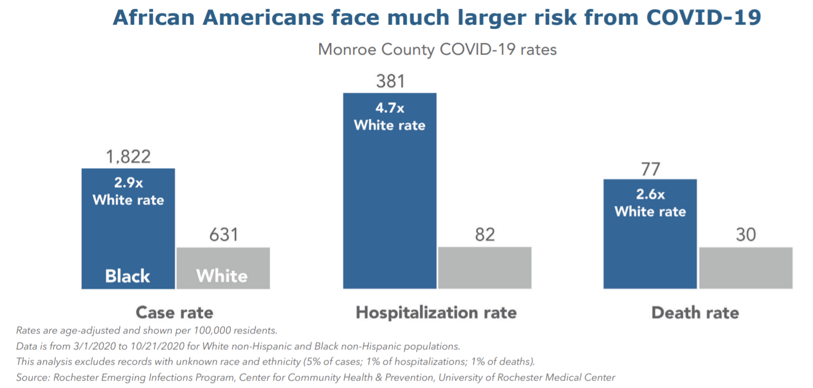
✎ Make at least three observations on the data presented.

✎ What story do these statistics tell about people in Monroe County?

Source 3:
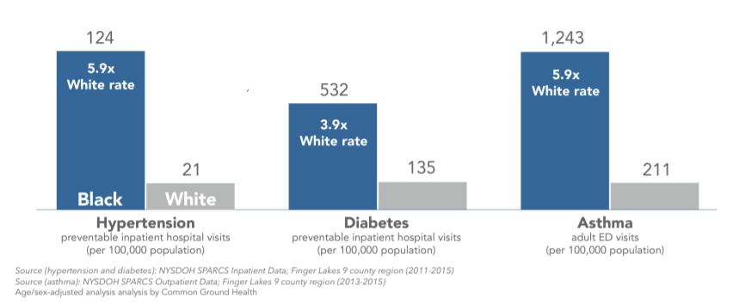
✎ Make at least three observations on the data presented.

✎ What story do these statistics tell about people in Monroe County?

Source 4:
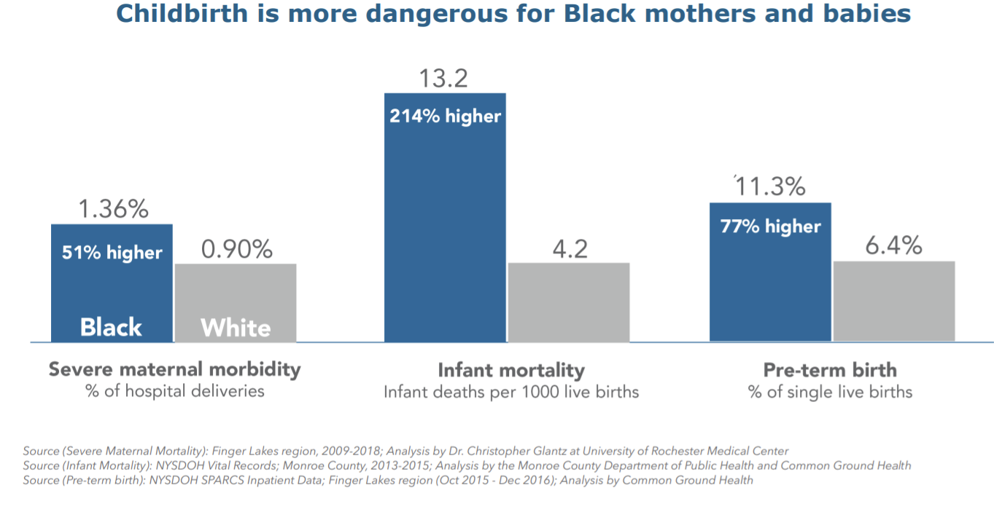
✎ Make at least three observations on the data presented.

✎ What story do these statistics tell about people in Monroe County?

Source 5:

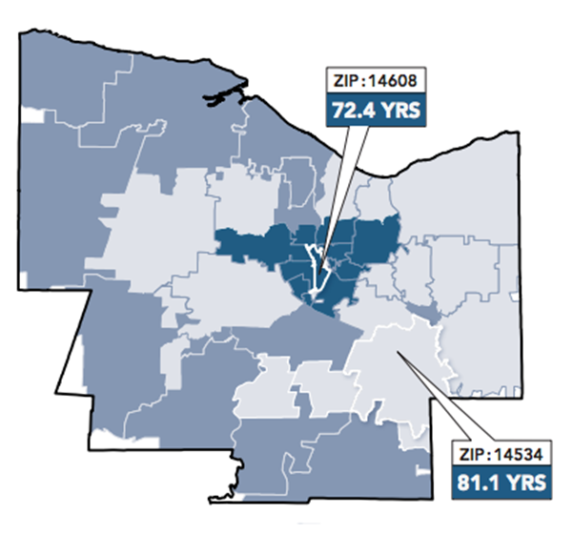
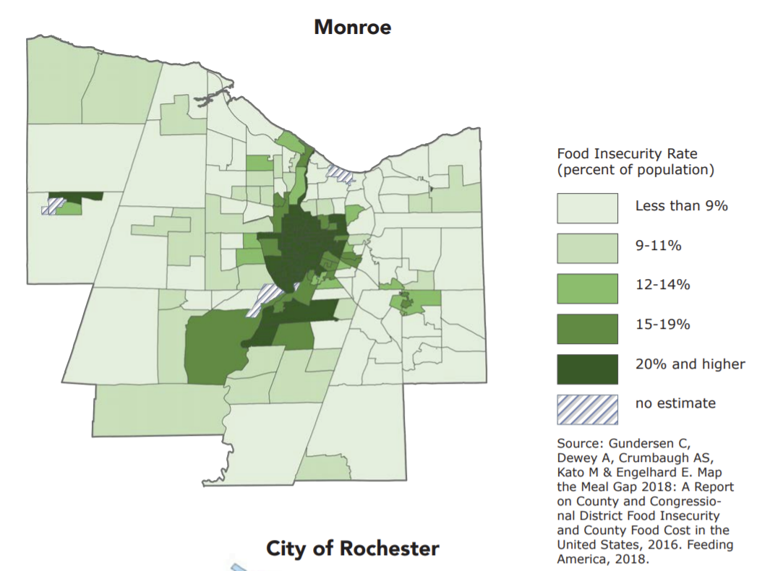


✎ Make at least three observations on the data presented.

✎ What story do these statistics tell about people in Monroe County?

